
June 2015
Casa Classroom Theme: Zoo Animals

What’s happening this month?

Friday, June 5 Field trip to the Toronto Zoo
Monday, June 8 Post-Dated cheques due
June 8, 10, 12 Casa Classroom Parent Observation Days
Thursday, June 11 Potluck Dinner
Thursday, June 18 4:30-5:30 Fathers’ Day Celebration
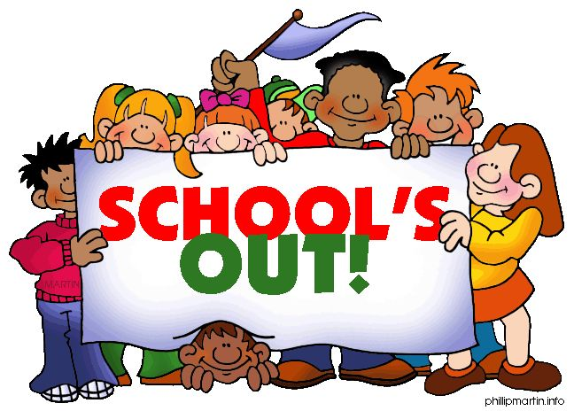
Friday, June 19 HAPPY BIRTHDAY to BENJAMIN!!
Sunday, June 21 Fathers’ Day
Thursday, June 25 Annual Spring Concert (tentative)
Friday, June 26 Last day of 2013-14 Academic Year
Monday, June 29 First day of Summer Camp
Tuesday, July 1 Canada Day! School/Camp closed



Field Trip: Metro Toronto Zoo

The Casa class will be going on a field trip to the Metro Toronto Zoo by TTC on Friday, June 5. Cost of the trip is $20 per child.

The Toddler class is invited if one parent can accompany their child on the trip.

Please confirm your child’s participation in the field trip with their teacher by Tuesday, June 2.
Casa Classroom - Parent Observation Days
Parents are invited to observe their child in the Montessori classroom to see how they work and interact.

Please select a day/time at the sign up sheet at the Casa classroom door; each parent can observe for 30 minutes. Available days are June 8, 10, 12.


Tiny Todd’s Potluck Dinner – Thursday, June 11
Please indicate what you would like to bring to our school potluck at your child's classroom.

Father’s Day Afternoon Tea – Thursday, June 18
Fathers and grandfathers are invited to our Fathers’ Day Afternoon Tea at 4:30-5:30 pm. Please indicate your attendance on the sign up sheet at your child’s classroom.
Spring Concert & Graduation
Thursday June 25, 2015* 6:30pm - 8:00pm
*Tentative date; more details to follow.
Summer Camp and 2015-16 School Year
The last day of school this year is Friday June 26, 2015. Summer Camp starts on Monday, June 29 and runs until September 4, 2015.
Post-dates cheques for Summer Camp, as well as for the 2015-16 School Year are due by June 8, 2015.

Please contact our principal, Shemin Peermohamed, if you have not received the fee schedule for September.
Tell your friends about Tiny Todd’s!
Parents who refer a new student to our school will be given a referral incentive.
Please contact Shemin for more details regarding this.

